Working with Documents – Exercise 2!
Welcome to your second document base assignment. In this document you will learn some advanced document functions.
Here is a checklist of what you will learn today. Each one that you master, add an X in the () like this (X).
Symbols () | Bullets and Numbering () | Changing Numbering style () | Changing numbering to start at 4 () | Colour and Highlight ()
Header() | Footer (Page Number) () | Page Orientation () | Hyperlinks () | Find and Replace ()

Getting Started
First, create a new document. Save it as Exercise 2

Symbols
In the future you may write with 1 or 2 special symbols. To practice, within the insert tab click symbol 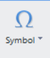 and add the Chinese Yuan symbol in the symbol Section..
Save your work

Bullets and Numbering
Bullets and numbering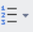 helps us to keep track of things in a list. You can change the way your bullets or numbers look by clicking the arrow beside the button and choosing another style.
Create a bullet list of activities you do in the morning before homeroom.
Save your work.

Numbering – Advanced
What happens if you want to change how a numbered list looks?
First, create a numbered list of 5 classmates around you. Then, right click on the number, and choose Bullets and Numbering…
You should see a screen like this:
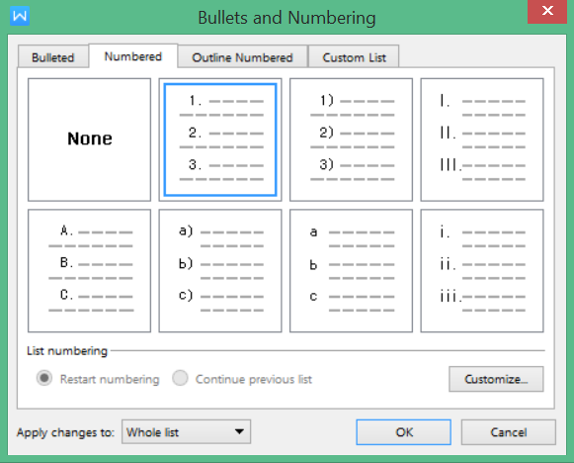
Change the numbering to a) b) c) and click OK.
But what if you wanted to start at a different number or letter?
Do the same thing again, but this time click the Customize…. button.
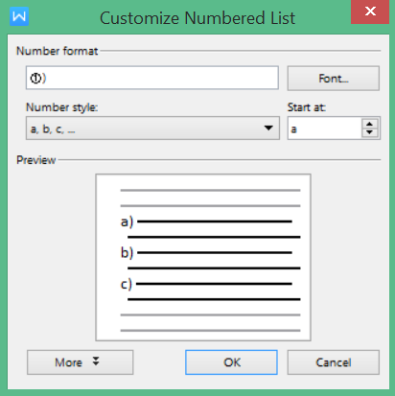 In the Start At box, start change the letter to the letter of your first name. If your name starts with a, then change it to z.

Colour and Highlight
Colouring a word can make our document look nicer. To colour a word, we select the words we want. Then we click to colour the word. If we want to choose a different colour, we click the arrow beside it.
To HIGHLIGHT something is to make something stand out with colour. We choose the words we want to highlight and click  to highlight the words.
Highlight and colour each of classmates in your list.
Save your work.

Header and Footer
A HEADER is the space you can put images or text on the very top of the document.
A FOOTER is the space you can put images or text on the very bottom of the document.
Both the header and footer can appear on all your pages in the document.
Choose the Insert tab 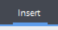 and choose Header and Footer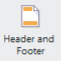.
Type your name in the header.
Now, click the close button 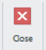 and go to the end of your document.
What makes this so special? Let’s take a look.
Click on the breaks 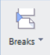 button and select Page Break. This make sure anything new you put onto the document starts on the next page.
You will see that your name is at the top of both page 1 and page 2.
Click on Page Number 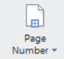 and choose Footer Middle.
Now you will see that each page has the page number at the bottom.
Save your work.

Page Orientation
PAGE ORIENTATION is how the words will look on the page. This page is in PORTRAIT VIEW, which means it is longer than wide. LANDSCAPE VIEW is when the page is wider than long.
To change the document to landscape view, click on the Page Layout tab (LAYOUT means the way the pictures and words look), and then the Orientation button. Then click on landscape.
Save your work.

Hyperlinks

A hyperlink (or link) tells people that there is something outside the document you can see, and looks like this: www.baidu.com
We can use links by pressing Ctrl on the keyboard and clicking on the link.

One easy way is to type a web address and press space right after (you need to type www or http:// in front of the site address).
Create a link to QQ on your document.

Another way is to create one yourself. Type the words CLICK ME on your document. Then select the two words and click on the Insert tab, the  button. You will see something like this:
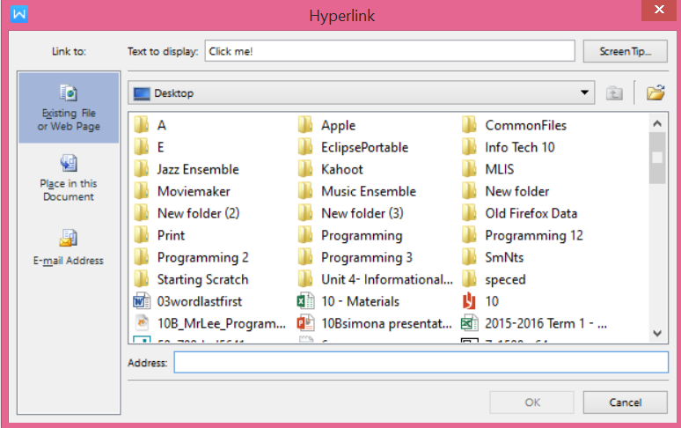
You can choose a file or website.
This time, in the address box, type in www.baidu.com

Removing A Link
Sometimes you don’t want a link to show. Create another link to Wuhan Maple Leaf home page. Right click on the link, and choose Remove Link. You will see that it does not have the blue colour and underline any more.

Find and Replace
Sometimes, we want to change a word that appears many times in our document.
Click on the home tab and click the button Find and Replace 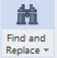 Here, you can find words in your document (when studying) or replace words (change words to another).
Copy this line into your document:
HiWorld HiWorld HiWorld HiWorld HiWorld HiWorld HiWorld HiWorld HiWorld HiWorld HiWorld HiWorld HiWorld HiWorld HiWorld HiWorld HiWorld HiWorld HiWorld HiWorld HiWorld HiWorld HiWorld HiWorld HiWorld HiWorld HiWorld HiWorld HiWorld HiWorld HiWorld HiWorld HiWorld HiWorld HiWorld HiWorld HiWorld HiWorld HiWorld HiWorld HiWorld HiWorld HiWorld HiWorld HiWorld HiWorld HiWorld HiWorld HiWorld HiWorld HiWorld HiWorld HiWorld HiWorld HiWorld HiWorld HiWorld HiWorld HiWorld HiWorld HiWorld HiWorld HiWorld HiWorld HiWorld HiWorld
Now find and replace all the “Hi” with “Hello”
Save your work.

